Tools, Files and Project Setup

Recommended Folder Structure
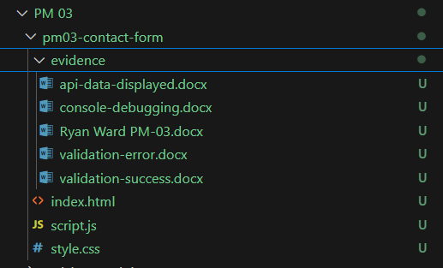

Practical Skill 3: Error hand with try…catch

Basic try…catch example

Try…catch with valid JSON
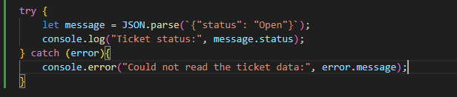
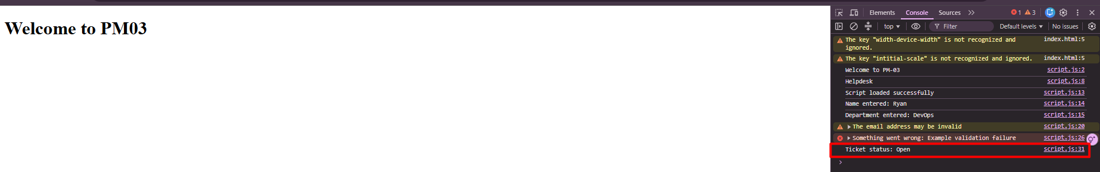

Try…catch with invalid JSON
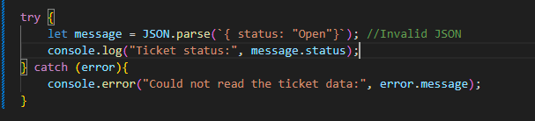
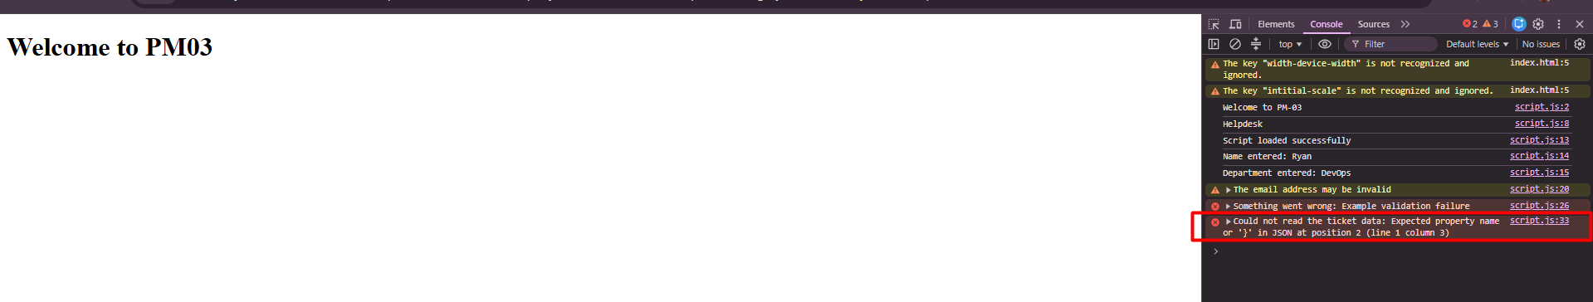

Finally block

Using finally
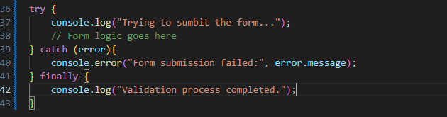
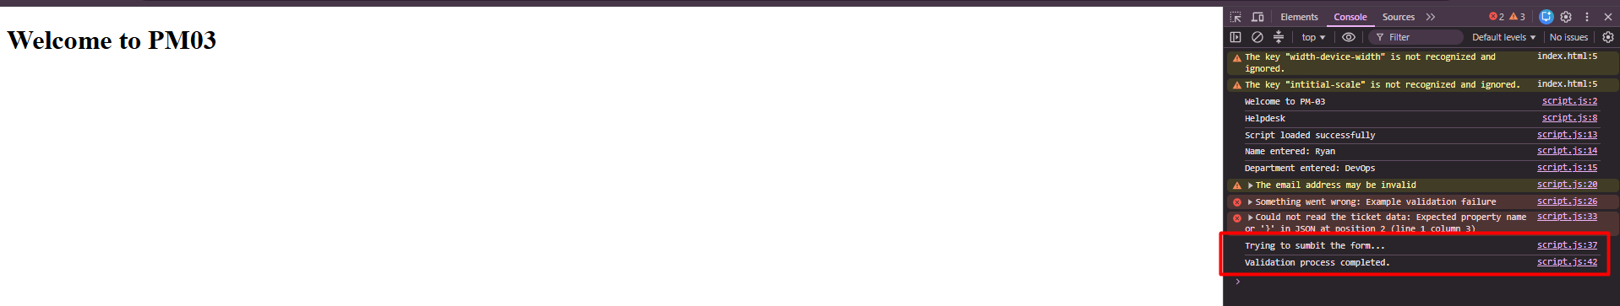

Workplace Example: Safe Department Lookup
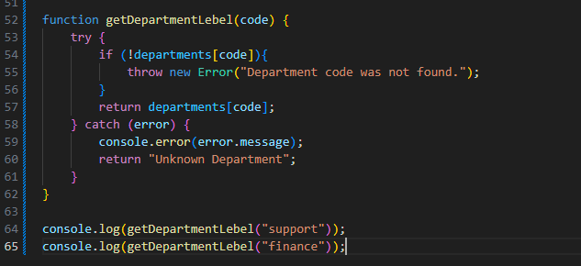
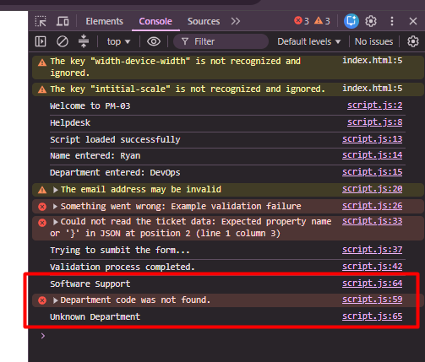

Practical Skill 4: DOM Manipulation

Selecting DOM Elements
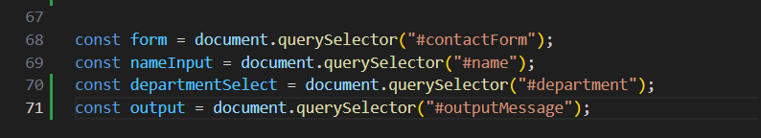

Reading input values
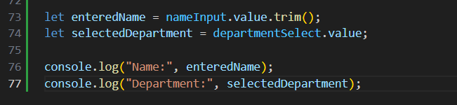

Changing Text on Page
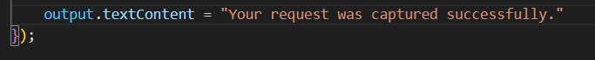
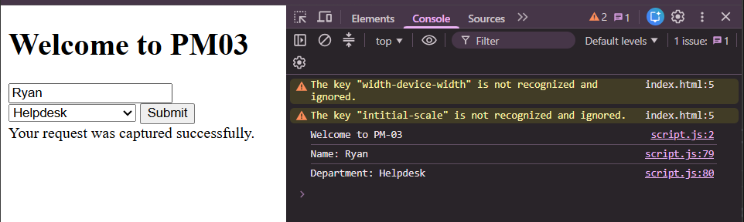

Changing Style on the Page
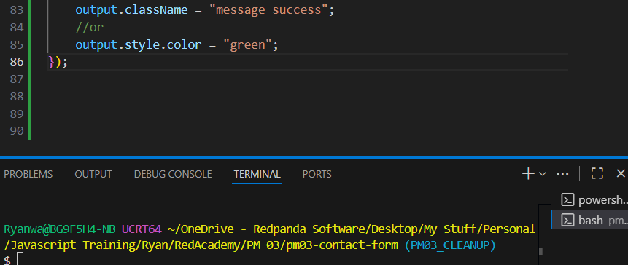
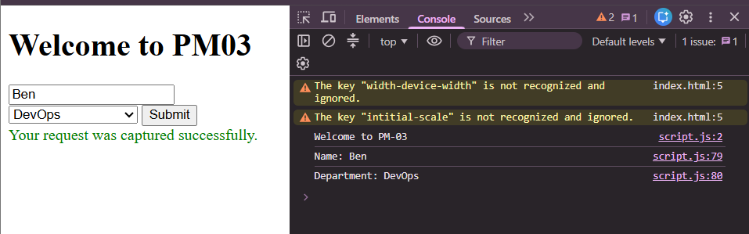

Adding Elements Dynamically
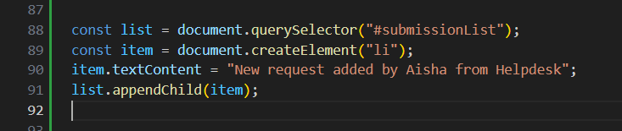
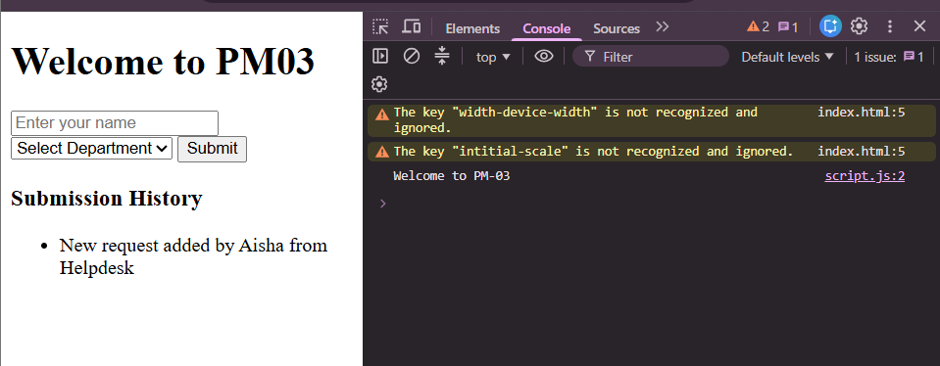

Removing Elements Dynamically
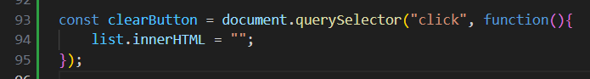
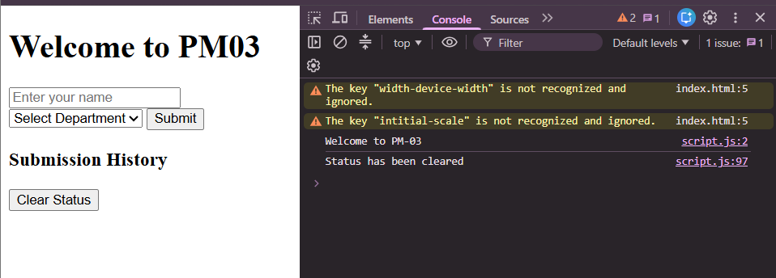

Practical Skill 5: Events

Click Event Example
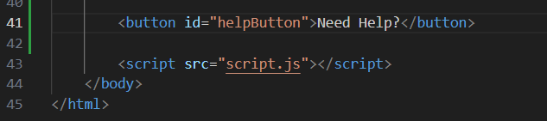
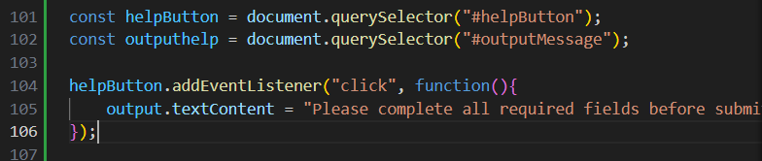
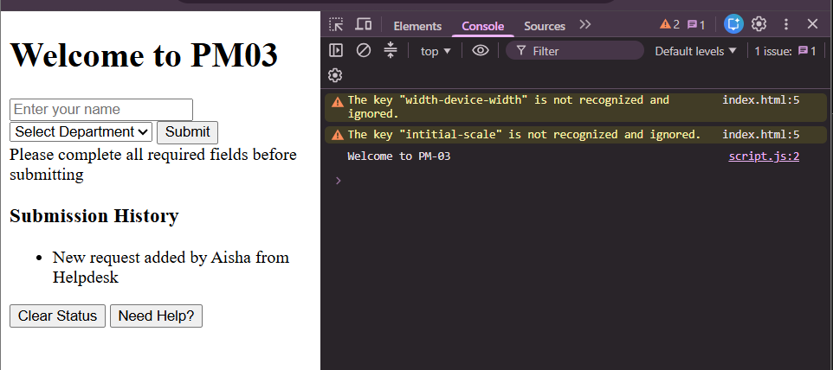

Submit Event Example
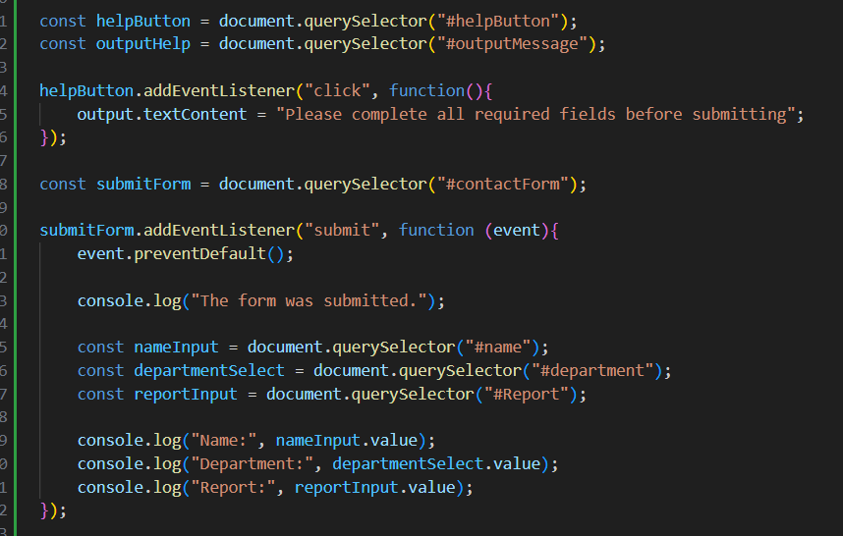
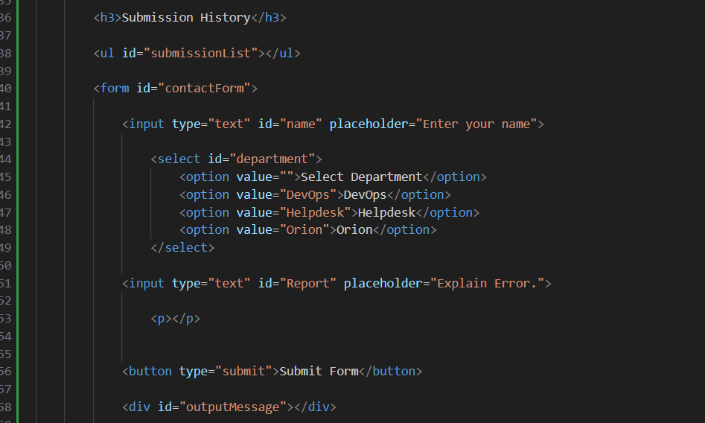
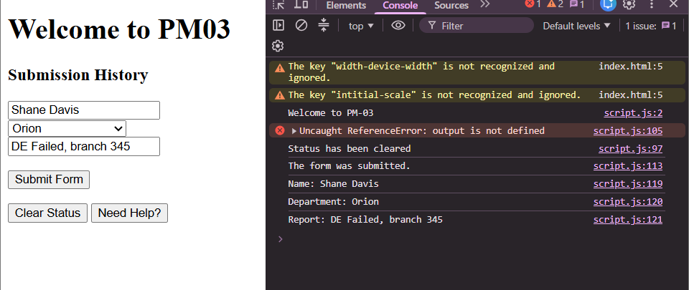

Input Event Example: Character Counter
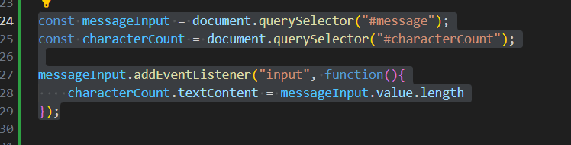
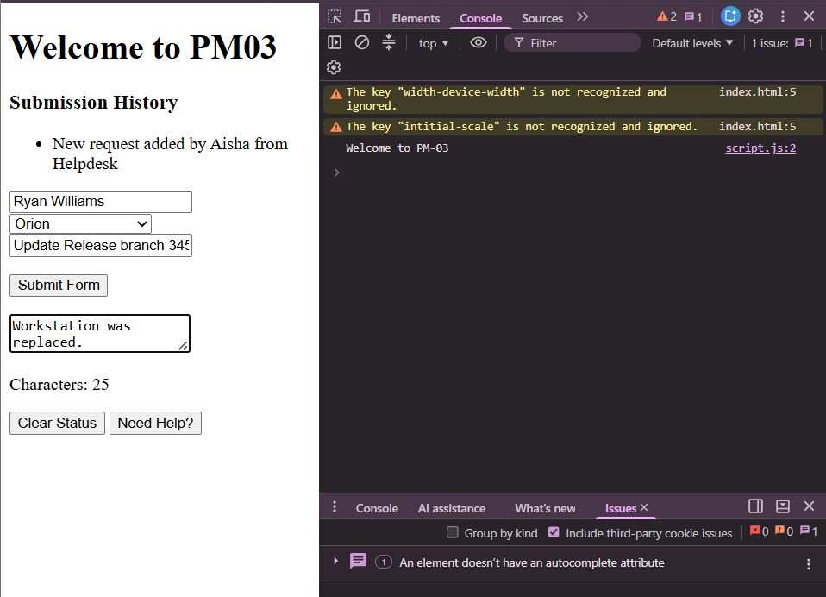

Practical Skill 6: Form Validation

Basic email validation
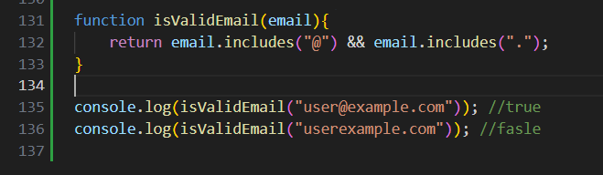
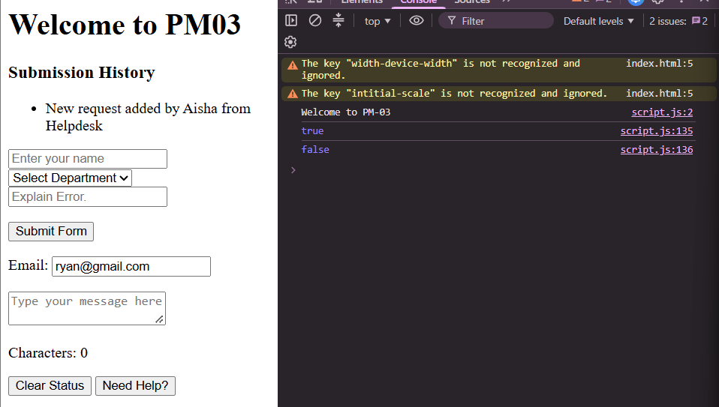

Slightly Better Email Validation Function:
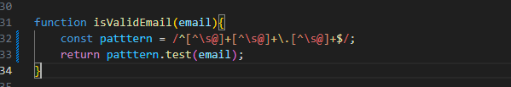

Show message function:
